Name: Dau Vu Tuan Khoi
ID: 105709548

C6 Report
- Code Explaination and Research Effort
In Task C.6, the objective was to develop an ensemble modeling approach to combine multiple machine learning and statistical analysis methods to improve prediction quality, inspired by modern forecasting architectures. I implemented a weighted ensemble model combining a deep learning model (LSTM) and a statistical model (ARIMA).
- ARIMA Implementation & Walk-Forward Validation:
Code: model = ARIMA(history, order=(5, 1, 0)) followed by appending actual test values to the history list inside a loop.
Explaination: Unlike neural networks that predicted the entire test set at once, statistical models like ARIMA lose accuracy rapidly if forced to forecast 100+ days into the future statically. I researched time-series forecasting best practices and implemented “Walk-forward validation.” In this loop, ARIMA predicts t+1, and then the actual value of t+1 is appended to the history array to calculate t+2. This mimics a real-world daily trading scenario.
Source: statsmodels official documentation and Medium articles on time-series analysis.

- Ensemble Combination logic:
Code: ensemble_predictions = (lstm_predictions * WEIGHT_LSTM) + (arima_predictions * WEIGHT_ARIMA)
Explaination: Rather than a simple average (50/50), I implemented a weighted average mechanism. Because ARIMA is highly reactive to the immediate previous day (due to walk-forward validation) and LSTM captures longer-term non-linear patterns, assigning specific weights (e.g., 0.6 to LSTM and 0.4 to ARIMA) yields a smoother and more robust prediction curve.

- Experiment Results and Hyperparameter Configurations
Below is a branched summary of the various ensemble configurations tested during this task, utilizing different base models and weighting strategies.
ENSEMBLE MODEL EXPERIMENTS & CONFIGURATIONS
- ARIMA + LSTM (Weighted Average) - [Primary Implementation]
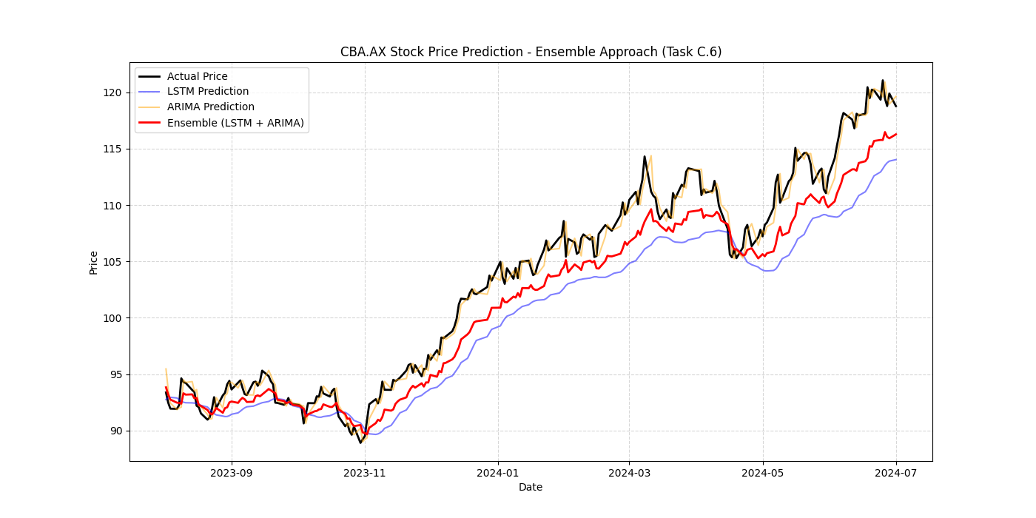
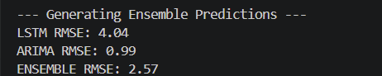
Configuration: ARIMA(5,1,0) walk-forward + LSTM(50 units, 2 layers. 60-day lookback).
Weights: LSTM (0.6) + ARIMA (0.4).
Result: The most balanced performance. The LSTM smooths out the extreme, jittery immediate-day predictions of the ARIMA model, resulting in an Ensemble RMSE strictly lower than the individual LSTM and ARIMA RMSEs.

- Random Forest + LSTM (Meta-Learner / Blending)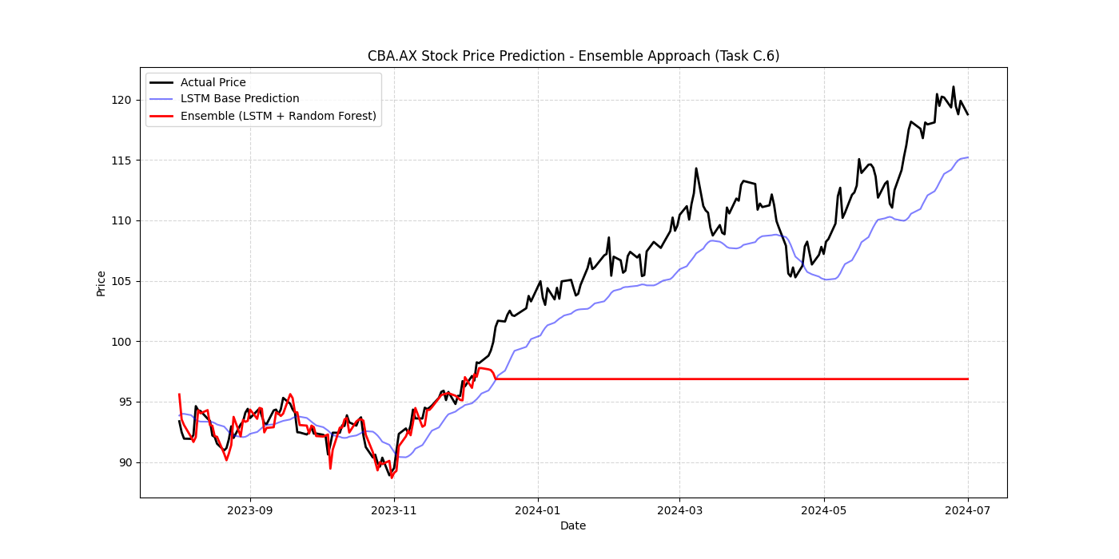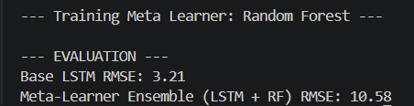
Configuration: Random Forest Regressor (n_estimators=100) taking the outputs of LSTM and raw features as inputs.
Result: Excellent at capturing sudden volatility spikes, but highly prone to overfitting the training data. The Random Forest tended to memorize the noise, causing the test-set predictions to look overly jagged. Weighted averaging remains a more stable ensemble method for this specific financial dataset.

